PAPER TITLE

First Author¹, Second Author¹, Third Author²

¹Institution
²Institution

Corresponding author:
Full name
Institution
Contact address
phone:
e-mail:

TITLE
Abstract

Keywords

Each article written in English must include an abstract in the same language - at least 6 lines, and a list of key words.
Each article written in Polish must include a title, an abstract (al least 12 lines), and a list of key words in English.

- Section title
The various components of your paper [title, text, heads, etc.] are already defined on the style sheet, as illustrated by the portions given in this document.
The template is used to format your paper and style the text. All margins, column widths, line spaces, and text fonts are prescribed; please do not alter them (each text should be submitted with single-lined spacing and preferably in a 10 point font size – Times New Roman).
Highlight a section that you want to designate with a certain style, and then select the appropriate name on the style menu. The style will adjust your fonts and line spacing. Do not change the font sizes or line spacing to squeeze more text into a limited number of pages. Use italics for emphasis; do not underline.
  - Subsection title
Do not add any kind of pagination anywhere in the paper.
Define abbreviations and acronyms the first time they are used in the text, even after they have been defined in the abstract. Do not use abbreviations in the title or heads unless they are unavoidable.
Do not number texts of section and subsection titles, tables, figures and also references – the template will do that for you.
Numbers of sections only to the second degree.
1.2. Positioning Tables
Place tables at the top and bottom of columns. Avoid placing them in the middle of columns. Large tables may span across both columns. Table heads should appear above the tables. Insert tables after they are cited in the text.
- Table description
Table Head | Table Column Head
Table Head | Table column subhead | Subhead | Subhead
copy | More table copyª
  - Positioning Figures
Place figures at the top and bottom of columns. Avoid placing them in the middle of columns. Large figures may span across both columns. Figure captions should be below the figure. Insert figures after they are cited in the text. Use the abbreviation “Fig. 1”. Figures added to the texts are to be of high resolution – 300 dpi.

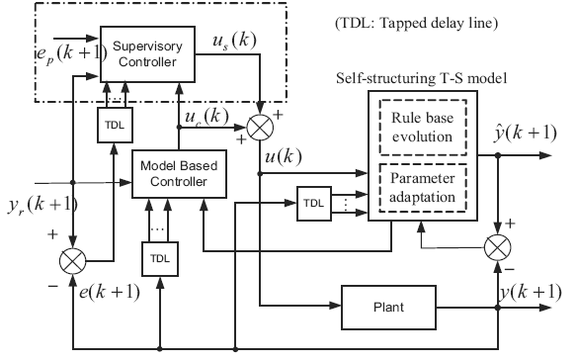
- Figure description
  - Equations
Number equations consecutively with equation numbers in parentheses flush with the margin, as in (1). First use the equation editor to create the equation. To make your equations more compact, you may use the solidus (/), the exp function, or appropriate exponents. Use parentheses to avoid ambiguities in denominators.
Italicize Roman symbols for quantities and variables, but not Greek symbols. Use a long dash rather than a hyphen for a minus sign. Punctuate equations with commas or periods when they are part of a sentence, as in
$α+β=χ$. (1)
Be sure that the symbols in your equation have been defined before the equation appears or immediately following. Italicize symbols (T might refer to temperature, but T is the unit tesla). Refer to “(1),” not “Eq. (1)” or “equation (1),” except at the beginning of a sentence: “Equation (1) is …”.
- Units
Use either SI (MKS) or CGS as primary units. (SI units are encouraged.). An exception would be the use of English units as identifiers in trade, such as “3.5-inch disk drive”.
Avoid combining SI and CGS units. This often leads to confusion because equations do not balance dimensionally. If you must use mixed units, clearly state the units for each quantity that you use in an equation.
Do not mix complete spellings and abbreviation of units: “Wb/m²” or “webers per square meter”, not “webers/m²”. Spell out units when they appear in text: “... a few henries”, not “... a few H”.
Use a zero before decimal points: “0.25”, not “.25”. Use “cm³”, not “cc”.
- Other recommendations
Reviewing of papers will be double-blind, so the authors should follow that:
- The authors' names and institutions should not appear in the paper.
- Using "we" or "us" in reviews of literature should be avoided, e.g., "In [1, 2] we have proposed..." should be changed to "In [1, 2] the authors have proposed...".

Use one space after periods and colons. Hyphenate complex modifiers: “zero-field-cooled magnetization.” Avoid dangling participles, such as, “Using (1), the potential was calculated.” [It is not clear who or what used (1).] Write instead, “The potential was calculated by using (1),” or “Using (1), we calculated the potential.”
- Conclusions
A conclusion section is not required. Although a conclusion may review the main points of the paper, do not replicate the abstract as the conclusion. A conclusion might elaborate on the importance of the work or suggest applications and extensions.

The preferred spelling of the word “acknowledgment” in America is without an “e” after the “g”. Avoid the stilted expression, “One of us (R. B. G.) thanks ...” Instead, try “R. B. G. thanks”. Put sponsor acknowledgments in the unnumbered footnote on the first page.

References
The template will number citations consecutively within brackets [3] and listed at the end of the manuscript in alphabetical order. The sentence punctuation follows the bracket [4]. Refer simply to the reference number, as in [5] – do not use “Ref. [5]” or “reference [5]” except at the beginning of a sentence: “Reference [5] was the first . . .”.
Number footnotes separately in superscripts. Place the actual footnote at the bottom of the column in which it was cited. Do not put footnotes in the reference list. Use letters for table footnotes.
Unless there are six authors or more give all authors' names; do not use “et al.”. Papers that have not been published, even if they have been submitted for publication, should be cited as “unpublished” [6]. Papers that have been accepted for publication should be cited as “in press” [7]. Capitalize only the first word in a paper title, except for proper nouns and element symbols.
For papers published in translation journals, please give the English citation first, followed by the original foreign-language citation.
References should be included in the order of citation.

- Eason G., Noble B., Sneddon I.N., On certain integrals of Lipschitz-Hankel type involving products of Bessel functions, Phil. Trans. Roy. Soc. London, A247, 529–551, April 1955.
- Elissa K., Title of paper if known, unpublished.
- Hanug K., Title of paper if known, in press.
- Jacobs I.S., Bean C.P., Fine particles, thin films and exchange anisotropy, Magnetism, vol. III, Rado G.T., Suhl H. [Eds.], New York, Academic, pp. 271–350, 1963.
- Maxwell J.C., A Treatise on Electricity and Magnetism, 3rd ed., vol. 2. Oxford, Clarendon, pp. 68–73, 1892.
- Qi R., Brdys M.A., Indirect adaptive controller based on a self-structuring fuzzy system for nonlinear modeling and control, Int. J. Appl. Math. Comput. Sci., 19, 4, 619–630, 2009.
- Young M., The Technical Writer's Handbook, Mill Valley, CA, University Science, 1989.

